# Setting up OpCon XML CommTester – Automatic Replies

To configure CommTester with automatic replies use the Server tool, which displays all received telegram. On the background, the server will be replying to the telegrams but these are not displayed on the Server window.

1. Open the CommTester folder. Open the *OpCon.XmlCommTester.exe.config* file with Notepad++. Set the sendResponse flag to true and add the path of the telegram replies.

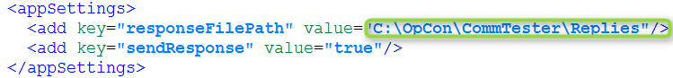

Figure 25. Changes to CommTester’s configuration file.

The following configuration is now mandatory but is important. By setting a path as seen in Figure 26, you will have a directory where CommTester will save every received telegram by the server.



Figure 26. Set the path to save the telegrams which will be received by the server.

Save the file and close it.

1. Go to the directory which you set for your telegram replies. Copy the telegrams which you want CommTester to send automatically. In this case, we want partReceived, plcChangeOverStarted and partProcessed.

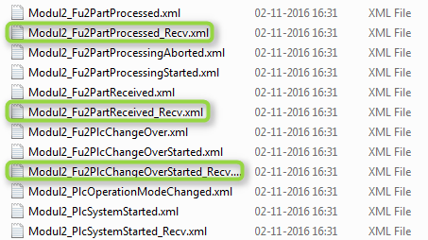

Figure 27. Telegrams in the Server Export folder of the OES project which should be copied to the CommTester reply directory.

1. Paste them in the folder you have defined in Step 15. You have to change their names in order for CommTester to recognize them. For instance, Modul2_Fu2PartProcessed_Recv.xml must become partprocessed.xml.

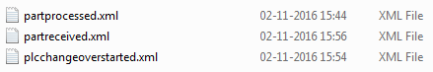

Figure 28. Telegrams in the Replies folder.

1. Make changes to the telegrams as you see fit. For instance, in the plcchangeoverstarted.xml file, add real values to the item structure to simulate a server reply. Basically, change the Dummy values to something more meaningful.

Also, in the partReceived telegram, change the changeover value to true in order to use the plcChangeOver and plcChangeOverStarted telegram. See picture below.

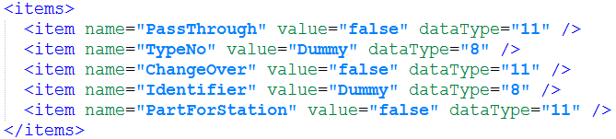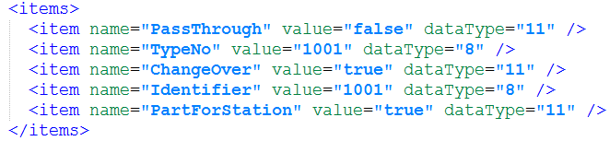

Figure 29. Before and after the telegram editing.

The CommTester configuration is now set up.

**Tip**: Firewall

If you are having trouble receiving the telegrams, it is possible that the firewall is blocking the communications. In order to overcome this, add the CommTester executable file to your firewall.

Go to *Control Panel* > *System and Security* > *Windows Firewall* > *Allowed Programs* to do this (valid for Windows 7). You only need to add *Public* networks to the exception.